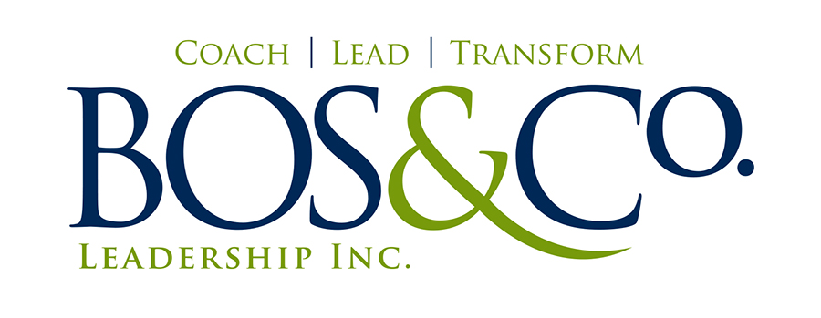

CARLO D. BOS, M.Ed., CPCC

**1788 Medallion Court**

**Mississauga ON, L5J 2L7**

**Canada**

**905-855-3633 /** [**carlo@carlobos.ca**](mailto:carlo@carlobos.ca) **/** [**www.carlobos.ca**](http://www.carlobos.ca)

#### PROFILE

A game-changing co-active coach and front-of-the-room leader who propels clients into compelling, purposeful, and “stretch” engagements that lead to significant shifts in mindsets, choices and powerful action. Is passionate about working with personal clients and accelerating leaders who want to lead in all aspects of the life and not settle – personally, professionally and beyond. Brings to life Co-Active Leadership and Coaching principles to design and facilitate compelling leadership forums, coaching engagements and workshops for audiences ranging in size from a few to a few hundred. Known for having intuition balanced with objectivity, humour balanced with gravity, and the ability to assist and champion clients in making transformational change. With a background in Economics and Psychology, and professional training from premier coaching schools, holds people and rooms with compassion, wit and a fierce desire for clients and leaders to live fully into possibility.

#### PROFESSIONAL EXPERIENCE

BOS & COMPANY LEADERSHIP INC. SEPT. 2012 - PRESENT

*A coaching and leadership development organization committed to bringing transformational experiences, learning and leader evolution to individual clients and organizations in a range of sectors; Financial Services, Non-Profit, Manufacturing, Automotive as well as private clients.*

***Founder and Lead Coach***

* Working with CPCC’s and graduate’s of CTI’s Leadership Program, co-designed and co-lead transformational leadership development programs to front line and senior leaders in two international organizations from the manufacturing and automotive sectors. The impact of this work lead to additional requests for facilitation (work is planned into 2014) and a shift in how leaders engage themselves and others purposefully. **Evoking transformation** the whole way!
* In partnership with MCC’s and PCC’s, provided impactful leadership coaching to accelerating leaders in a specialized financial services company, shifting the culture to one of more open dialogue, curiousity and self-belief. **Coach the Whole Person** – you bet!
* Launched and continue to build an inspired personal coaching practice targeted at clients in the prime of their career and lives, calling them into values-centered life leadership and to designing a life without settling. At any given time, this practice has on average 8 active clients.
* Co-designed and co-lead the CONNECT TO Lead program with an international partner, rolling the program out to 3 leadership teams and participants in Canada and the U.S. **International Co-Activity!**
* Exceeded revenue targets in the first year of business (in excess of six figures) while establishing a solid pipeline of activity through intentional partnerships throughout the year.

KNIGHTSBRIDGE HUMAN CAPITAL MANAGEMENT 2005 – PRESENT

*One of Canada’s leading human capital consultancies, Knightsbridge works with clients to develop a robust, integrated life-cycle for leaders in organizations, from recruitment and attraction to retention and development, workforce planning and how to successfully exit organizations.*

**SENIOR ASSOCIATE CONSULTANT, Knightsbridge Leadership Solutions, 2012 – PRESENT**

* Co-lead a pivotal leadership development program with a significant telecommunications client, navigating the complexities of having 4 distinct levels of participants in the room (front line leader to VP). Secured average performance/impact ratings of 9.2/10 over the three-day delivery. Used Co-Active Coaching and Leadership principles as a team coach and front-of-the-room leader, which helped to secure 6 additional modules of work and significant recognition from key client sponsors. **Deepen Learning and Forwarding Action** (and results).
* Co-lead a culture-defining leadership development program with a key financial services client, working at three levels across the organization (Senior Manager, Director, VP’s). Secured average impact ratings of 8.5-9/10 on facilitator effectiveness and participant satisfaction, and received a 100% rating from the lead client who attended the final session. Received multiple requests to serve as an Executive Coach for VP’s in the business.
* Co-lead a coach training program with another CPCC for mid-to-senior level leaders in a global professional services company and worked as the lead team coach/facilitator for leaders learning coaching skills across the country. Set the bar for group coaching facilitation, received 88%+ effectiveness ratings on average and established a training video for future facilitators to follow in subsequent training events. The impact of **Leading from a Stake and being Co-Active!**
* Build and maintain a book of executive coaching clients averaging 8-10 at any given time, most at the Director/VP/GM level.

**SENIOR CONSULTANT, LEADERSHIP SOLUTIONS, 2008 – Sept. 2012**

* Coached up 16 mid-level leaders (Director/VP) at a leading telecommunications firm to achieve new levels of self-awareness, commitment and clarity in their personal and professional leadership. As a coach and program leader, secured 3 successive mandates, engaging in excess of 150 leaders, strengthening succession initiatives and leading to a more intentional, collaborative culture. **Infusing NCRW in the community** of leaders.
* Co-lead a leader forum for 300 leaders in a leading Canadian Retailer which served leaders to become more connected, clear and innovative in overcoming significant organizational obstacles. Using a powerful stake with a non-CTI trained leader and creating from everything (delays, distractions and more), generated strong accolades and feedback on our presence, down-to-earth delivery and impact in challenging circumstances. We **danced fiercely** that evening!
* Worked with a global Consumer Packaged Goods organization as an executive coach and front-of-the-room leader over a two-year period. Coached 3 executives (VP and SVP) to new levels of clarity, effectiveness and promotion. Co-lead team effectiveness offsites using co-active leadership strategies to deepen connection and create compelling action and commitments with two of the most senior teams. Leaders developed more **curiousity** and heighted **self-management** as a result of the programs
* Consistently met or exceed sales and delivery objectives, being recognized in 2009 as a Diamond contributor to the organization.

**SENIOR CONSULTANT/CONSULTANT, CAREER TRANSITION, 2005 – 2008**

* Worked with outplacement clients in providing personal counseling, support and references when transitioning to new roles or career fields. Used client-centered techniques to interview, understand, and assist clients in moving forward during times of stress and anxiety.
* Facilitated in-house group sessions for up to 30 individuals on career transitions strategies, including how to deal with the stress of change and effectively manage the career transition process to secure the next opportunity. **Evoking transformation** baby!
* Worked with a major Canadian retailer in providing “Managing Change” workshops to over 125 employees directly and indirectly impacted by a major restructuring. This included using Kebler-Ross’s Stages of Change and tips to managing anxiety and stress. Overall feedback revealed that the sessions were seen as either “Effective” or “Very Effective” in over 85% of cases. **We are all NCRW**, even in times of stress and change.
* Maintained a book of coaching clients up to 50 and exceeded all yearly targets.

KNEBEL WATTERS & ASSOCIATES 2003 – 2004

**JOB SEARCH PARTNERS© COACH**

* Delivered performance and results similar to Career Transition Consultant above

KCI KETCHUM (formerly KETCHUM CANADA INC.) 1999 – 2003

**Campaign Director, Consultant, 2001 – 2003**

**Associate Campaign Director, 1999 – 2000**

* Directed ten parish campaigns for the Anglican Diocese of Calgary, exceeding expectations by raising $1.2-million in three months and taking one parish campaign 400% over goal.
* Coached over 200 volunteers (from business and the community) across the healthcare, education and religious services sectors on fundraising and marketing strategies, designing several company precedents in the process. In working with volunteers, **called them to their values**for the sake of service and personal growth.
* Played a lead role on a four-person team in the Anglican Diocese of Niagara’s $8-million campaign. Facilitated training sessions for over 400 volunteers which resulted in 32 parishes raising over $3-million in eight months.

**Prior to 1999, held a variety of positions in Sales, Finance, and Hospitality, including serving as the General Manager of the Brisbane Homestead Travellers Hostel in Brisbane, Australia.**

**EDUCATION**

Masters of Education, Counseling Psychology, University of Toronto

Bachelor of Arts, Honours, Queen’s University at Kingston

**PROFESSIONAL DEVELOPMENT**

|  |
| --- |
| BeAbove Leadership – Transformational Coaching and Neuroscience, 2013 (in progress) Coaches Training Institute – CPCC Certification, 2013  Bigger Game Living Retreat, 2012  Coaches Training Institute – Co-Active Leadership Program, Birch Tribe, 2012  Coaches Training Institute – Co-Active Coaching Core Curriculum, 2011  Knightsbridge Leadership Solutions – Leadership Coach Training, 2010 The Coaching Clinic – Training Program, Corporate Coach U, 2008The Birkman Method®, Certification & Training, 2008DISC Training, 2005Using Solution Focused Therapy to Resolve Complex Issues, Hincks-Dellcrest Centre, 2005 |
| Critical Incident Stress Debriefing – Introductory Seminar, University of Waterloo, 2005 |
| Mindfulness-Based Meditation and Stress Reduction Course, St. Joseph’s Health Centre, 2004 |
| Leadership and Emotional Intelligence Training, Vezina & Associates, 2001 – 2003 |

**COMMUNITY LEADERSHIP**

Lakefield College School, Board of Trustees, 2011 – present

Fairfields Swimming Club, Facilities Volunteer, 2011 – present

Clarkson T-ball Association, Coach, May 2013 – present

Camp Oochigeas, Volunteer Counsellor and Program Leader – 2003 - 2006